**1. INTRODUCTION**

In the realm of healthcare and medical diagnostics, the battle against lung cancer has taken a significant stride forward with the advent of advanced technologies. Our college project harnesses the power of Convolutional Neural Networks (CNN) and deep learning to create a cutting-edge solution for lung cancer detection. Lung cancer is a formidable adversary, often diagnosed in later stages when treatment options are limited. However, our CNN-based approach aims to revolutionize early detection through the analysis of medical imaging data, including chest X-rays. By leveraging the capacity of deep learning, our system can identify potential malignancies with remarkable accuracy, offering the promise of timely intervention, improved patient outcomes, and a crucial step toward reducing the global burden of this devastating disease within our college community.

**OBJECTIVE:** The primary objective of the project is to develop and implement a Convolutional Neural Network (CNN) based system for the early detection of lung cancer using medical imaging data, primarily chest X-rays. I aim to create a robust and accurate model capable of identifying potential malignancies with a high degree of precision. Through rigorous training and evaluation, I seek to demonstrate the effectiveness of deep learning techniques in improving the efficiency of lung cancer diagnosis. The ultimate goal of my project is to contribute to the field of healthcare technology by providing a reliable tool for early detection, potentially enhancing patient outcomes and reducing the burden of this disease.

**MAJOR MODULES:**

* Module 1 – Index
* Module 2 – Prediction
* Module 3 – Analysis
* Module 4 – Train and test model

**Functionalities of Modules:**

**Index**: This is the index or home page of the project. It presents the user with various information about the project like, technologies used in the project and about the project. The user can also navigate to various sections of the page using navigation links.

**Prediction**: This module enables the user to interact and use the trained model to predict lung cancer by inputting various data such as chest X-ray and other patient details. The response is generated quickly and in real time.

**Analysis**: This module comprises of various analytical aspects of the project using the dataset. Analytics like age diseases by patient gender, or finding diseases, or view positions and more. Various classifications are also presented with the help of this module.

**Train & test model**: In this module we have trained and tested three different models using 3 different methods. This is by far the most time-consuming module as this comprises of training the model on a large data set. This module also has metrics to measure precision, recall and Fscore.

* Optimized CNN – Created a model using only 64x64 images instead of its original height and width as the model was able to recognize the patterns even in a 64x64 image and also uses spatial transformer. Hence to improve performance and reduce space we can use this model.
* Vanilla CNN – This is the original unaltered algorithm of CNN used to train and test the model. Also, this method does not use spatial transformer.

**2. Requirement Specifications**

In this section we will look at the various requirements needed to run and deploy this project. As a pre-requisite some basic computer and programming knowledge will be required in order to setup the code base.

**Software requirements:**

* Python 3.11.x
* Code editor
* Terminal
* Windows 10/11
* Web browser.
* Python libraries to be installed:
  + TensorFlow
  + NumPy
  + OpenCV
  + Matplotlib
  + Flask
  + Scikit-Learn

**Hardware requirements:**

* RAM: 8GB - 16GB DDR4
* CPU: Multicore CPU with at least 4-8 cores
* GPU: VRAM of 4GB – 8GB
* Storage: 60GB – 100GB
* Internet connectivity to train and test model online (optional)

**3. Software Description**

The Lung Cancer Detection System is a software application designed to assist healthcare professionals in the early detection of lung cancer. This innovative tool combines cutting-edge technologies in machine learning and medical image analysis to analyze medical images, such as X-rays, and provide valuable insights into potential lung cancer lesions. The system aims to improve the accuracy and efficiency of diagnosis, ultimately enhancing patient outcomes.

**Key Features**

* **Medical Image Analysis**: The system's core functionality involves the analysis of medical images to identify suspicious areas in the lungs. It employs advanced algorithms to detect and categorize potential cancerous lesions.
* **Machine Learning Models:** The system incorporates machine learning models trained on a comprehensive dataset of lung images. These models continuously learn and adapt, improving their accuracy over time.
* **User-Friendly Interface**: To ensure seamless integration into clinical practice, the system boasts an intuitive and user-friendly interface. Healthcare professionals can easily upload images, view results, and access diagnostic insights.
* **Performance Metrics:** The software provides detailed performance metrics to evaluate the accuracy of its predictions. This includes sensitivity, specificity, and positive predictive value (PPV), enabling clinicians to make informed decisions.

**Technical Stack**

* **Programming Languages:** The software is primarily developed using Python, making use of popular libraries such as TensorFlow and scikit-learn for machine learning tasks.
* **Image Processing:** It employs OpenCV for image preprocessing and manipulation, enhancing the quality and suitability of input images.
* **User Interface:** The user interface is designed using HTML/CSS and JavaScript, ensuring cross-platform compatibility.

**Use Cases**

The Lung Cancer Detection System is intended for use in clinical settings by radiologists, oncologists, and other healthcare professionals. Its primary use cases include:

* **Early Detection:** Identifying potential lung cancer lesions at an early stage, enabling timely intervention.
* **Treatment Planning:** Assisting in the development of personalized treatment plans based on the severity and location of detected lesions.
* **Progress Monitoring:** Continuously monitoring changes in lesion size and characteristics over time to assess treatment effectiveness.

**Conclusion**

This section provides an overview of the Lung Cancer Detection System's software components, features, and technical stack. In subsequent sections of this documentation, we will delve deeper into each aspect, discussing system architecture, data flow, algorithmic details, and user interface design. This comprehensive understanding will equip users and developers with the knowledge needed to effectively utilize and maintain this vital tool in the fight against lung cancer.

**4. System Analysis**

In this section, we conduct a system analysis for the Lung Cancer Detection System, developed by a solo developer, with a focus on understanding its purpose, requirements, and constraints.

The primary purpose of the Lung Cancer Detection System, created by a solo developer, is to enable the early detection of lung cancer through the analysis of medical images, specifically X-rays. The key objectives include:

* Enhancing the accuracy of lung cancer diagnosis, particularly in early stages.
* Aiding healthcare professionals by providing valuable diagnostic insights.
* Offering a practical, standalone solution for lung cancer detection.

**Requirements**

**Functional Requirements**

* **Image Analysis:** The system should accurately analyze medical images (X-rays) for potential lung cancer lesions.
* **User Interface:** Develop an intuitive user interface that allows for image upload and presents analysis results in an easily interpretable format.
* **Machine Learning:** Implement machine learning models for lesion detection and classification, ensuring that these models can adapt and improve over time.
* **Data Management:** Create a secure data storage system for managing patient data and images, prioritizing data privacy.
* **Performance Metrics:** Incorporate performance metrics, such as sensitivity, specificity, and positive predictive value (PPV), for evaluating diagnostic accuracy.

**Non-Functional Requirements**

* **Accuracy:** Strive for a high level of accuracy in lesion detection and classification to instill confidence in the system's results.
* **Usability:** Ensure that the user interface is intuitive and user-friendly, requiring minimal training for healthcare professionals.
* **Scalability:** Design the system in a way that allows for future enhancements and scalability if additional features or capabilities are required.
* **Security:** Prioritize data security to protect patient information, adhering to relevant data protection regulations.
* **Performance:** Optimize system performance to handle image analysis efficiently and provide rapid results to users.

**Constraints**

As a solo developer, there are certain constraints that need to be considered:

* **Resource Limitations:** Limited resources in terms of time and manpower may affect the speed of development and testing.
* **Expertise:** The developer's expertise in both healthcare and software development may influence the system's capabilities and complexity.
* **Budget:** A solo developer may have budget constraints, potentially limiting access to specialized tools or technologies.

**Conclusion**

This system analysis provides insight into the Lung Cancer Detection System developed by a solo developer. It outlines the system's purpose, functional and non-functional requirements, and constraints. While the project may face limitations in terms of resources and expertise, it demonstrates the potential for a single developer to contribute significantly to the advancement of lung cancer detection through innovative software solutions.

**Algorithm and methods**

This is a problem with the new datasets that have never been fully modeled, so I do not want to get stuck, and so I come up with the following approach:

**Convolutional Neural Network**

A CNN, or Convolutional Neural Network, is a deep learning algorithm primarily designed for processing and analyzing visual data, such as images and videos. CNNs have become the foundation for various computer vision tasks, including image classification, object detection, facial recognition, and more. They are exceptionally effective at extracting relevant features from complex visual data, some parameters are considered and used as follows:

* Neural network architecture: Choose the appropriate architecture
* Preprocessing parameters
* Fine tuning
* Spatial transformer
* Add more data in network not only images
* Convolution Layers: CNNs employ convolutional layers to scan input data (e.g., an image) using small filters or kernels. These filters move across the input, computing dot products at each location. The result is a feature map that represents localized features within the input.
* Pooling Layers: Pooling layers, typically max-pooling or average-pooling, reduce the spatial dimensions of the feature maps while retaining the most important information. Pooling helps make the model more robust to variations in scale and position.
* Convolutional Neural Network Architecture: CNNs often follow a specific architecture pattern, consisting of multiple convolutional layers followed by pooling layers, followed by one or more fully connected layers. The final layer produces output predictions based on the learned features.
* Feature Learning: CNNs are capable of automatically learning hierarchical features from the data. Lower layers capture simple features like edges and corners, while deeper layers capture more complex features and patterns.
* Weight Sharing: CNNs share weights (parameters) across the input data, which significantly reduces the number of parameters compared to fully connected networks. This weight sharing helps in learning translation-invariant features.
* Activation Functions: Non-linear activation functions (e.g., ReLU - Rectified Linear Unit) are applied to the output of each convolutional layer, introducing non-linearity into the model and allowing it to capture complex relationships in the data.
* Dropout: Dropout is a regularization technique commonly used in CNNs to prevent overfitting. It randomly drops a fraction of neurons during training, forcing the network to become more robust.

CNNs have achieved remarkable success in various computer vision tasks and have been used in the development of self-driving cars, facial recognition systems, medical image analysis, and more. They have also been used for tasks beyond computer vision, such as natural language processing when combined with recurrent neural networks (RNNs) to form hybrid models like CNN-RNNs.

**Metrics**

The evaluation metrics used here will be precision, recall and F-beta scores (beta is 0.5) for binary classification – found diseases or not. In this case F score is better than accuracy because with binary classification found diseases or not, the classes are imbalanced. For example, consider you have a trivial classifier that just guesses the majority class, it will obtain 80% accuracy when there is an 80/20 split and 50% accuracy when there is a 50/50 split.

These indexes will be evaluated on a separate testing data set from the original dataset.

These indicators will be evaluated for all diseases – found disease or not.

If the case is positive and not negative, then the indicators:

tp: True Positive - The number of people affected is expected to be affected

fp: False Positive - The number of people who are sick is predicted to be unwell

fn: False Negative - The number of people without the disease is predicted to be wrong

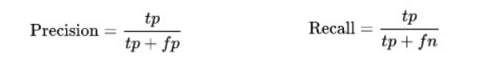

Precision and Recall will focus on the number of people expected to be affected, thereby

overcoming the skew data status and the importance of predicting a person's illness.

Precision represents the proportion of people who correctly predicted the disease in the total number of people who were predicted to be sick. Recall represents the proportion of people who correctly predicted illness on the total number of people actually infected. Both of these indicators are very important in predicting the disease, and we need an index that can be both Precision and Recall.

From here we have a combination of Precision and Recall F score:

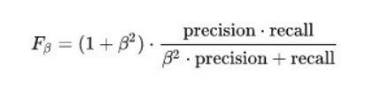

With different β will show the importance between different and precision different. There are two main ideas for choosing the importance of precision and recall:

* Models need to be sure that a patient is expecting a disease, which means that each expectation is highly confident because when a patient is diagnosed with a disease, it is very shocking. It is very important, as this is a method to assist doctors with other diagnostic procedures. So, we want high precision and low recall, corresponding to small β, taking β = 0.5 for F beta score.
* Models need to avoid mispronouncing sick people to avoid illness, avoiding missing patients at risk. This case will select low precision and high recall, corresponding to large β, taking β = 2 for F beta score.

For the purpose of this project is to prove the technology as well as support the doctors in diagnosing the disease because to determine the disease will need many tests on the patient. The patient will be anxious before knowing further results, so I choose F-0.5-score is β = 0.5. With β = 0.5 to represent precision will be more important than recall in this case.

**Data Preprocessing**

My preprocessing data for both sample dataset and full dataset in “Data preprocessing” notebook consists of following steps:

* For images:
* The images are rescaled, reducing the size of the image reduces the feature that makes training faster.
* The images are converted to gray and RGB. Both are used for different models.
* Read the image to NumPy array then normalize by dividing the image matrix by 255
* For extra data:
* Separate individual features into individual features.
* Standardize the age field to the numeric form and, according to the year, then normalization field
* Remove the outliers point due to data about age too large.
* One hot two important attributes they will use are 'Patient Gender' and 'View Position'
* Random both dataset

All data after processing is stored for later use.

The preprocessing process has the following adjustable parameters: Images resize shape

**Implementation**

This is the main method of this project and can be seen on notebooks: “Optimized CNN - Full Dataset” and “Optimized CNN - Sample Dataset”.

Here is the Architecture for this approach:

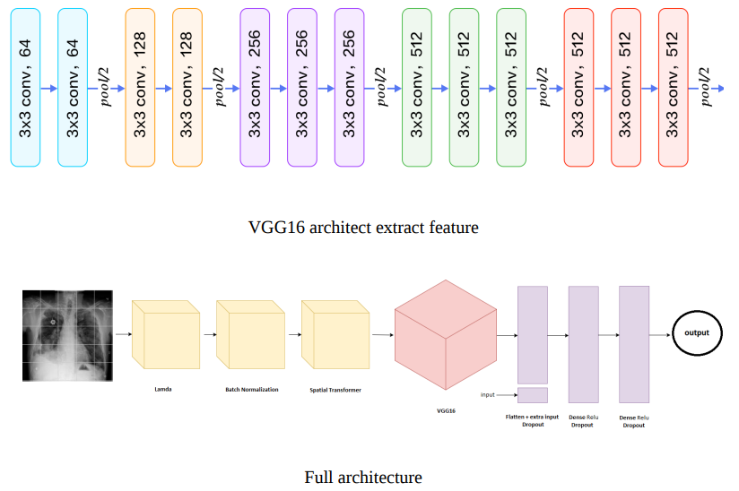

The architecture consists of three main layers in the following order:

* Spatial transformer layers (The first three layers)
  + ◦ The first is lambda to transfer the routing features [-0.5: 0.5], which means that the features of the image have an average value of 0.
  + The second is Batch Normalization.
  + The third layer is Spatial Transformer, which is used to extract the most valuable features for classification.
* Extract features layers (VGG16 pretrained model)
  + A set of 13 layers as shown in the first image of the VGG is the extract features, there are many pretrained model but now I am trying before with VGG16 because this is a simple model for learning time and training faster.
* Classification layers (Last 3 layers)
  + The first layer is the Flattened layer from the output of the layers VGG16 and 5 features plus 'Age', 'Gender Male', 'Gender Female', 'View position AP', 'View position PA'. These additional features will also affect the sorting, as we have seen above, so they are added to this layer. Following this layer is the dropout layer.
  + The next two layers are Dense after each Dropout layer, with a gradual decrease in depth.

The order of steps is as follows:

* Load data has been processed into ram, data is processed as before. Images are in RGB format.
* Implement Network architecture as designed by the architect.
* Implement Metric function including Binary accuracy, Precision score with threshold, recall score with threshold, Fbeta score with beta and threshold.
* Implement data generator, model checkpoint, model loss function.
* Training model with training parameters, logging training / validation loss and training / validation accuracy.
* Save best model and test model on testing set.

**5. Data Flow Diagram**

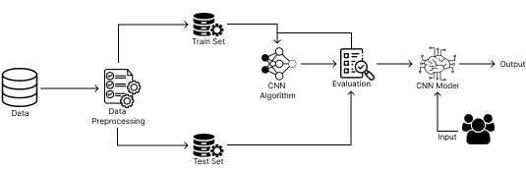

1. Data Source: The starting point where you acquire medical datasets containing images of lung scans. These datasets can come from various sources such as hospitals or research institutions.
2. Data Preprocessing and Augmentation: This process involves cleaning, enhancing, and augmenting the acquired dataset to improve its quality and diversity. Data preprocessing may include tasks like noise reduction and image resizing.
3. Dataset Preparation (Training and Testing): The dataset is divided into training and testing sets for machine learning model development and evaluation.
4. Machine Learning Model Training: Using the training dataset, machine learning models are trained to detect lung cancer lesions. This process involves feature extraction, model training, and parameter tuning.
5. Trained Model and Configuration: After training, the machine learning model and its configuration are saved for later use in the system.
6. User Interface (Image Submission): Users (typically healthcare professionals) submit medical images through the user interface for analysis.
7. Image Processing and Preprocessing: The uploaded images undergo preprocessing to prepare them for analysis. This may include standardization, noise reduction, and image enhancement.
8. Image Analysis (Lung Cancer Detection): The preprocessed images are analyzed using the pre-trained machine learning model to detect lung cancer lesions.
9. Diagnostic Report (Result Presentation): The system generates diagnostic reports based on the analysis results and presents them to the user through the user interface. These reports include information on lesion presence, location, and classification.

This DFD begins with the acquisition and preparation of the dataset, which is a critical step in training your machine learning model for lung cancer detection. The flow then proceeds through image submission, analysis, and result presentation. Depending on the specifics of your system, you may need to further expand or refine this DFD to include additional processes or details.

**6. Source Code**

The source code of this project will be classified into 2 parts: the back-end and the front-end.

**Front-end:**

**Index.html**

<!DOCTYPE html>

<head>

<meta charset="utf-8">

<meta http-equiv="X-UA-Compatible" content="IE=edge">

<title>Lung Detect</title>

<meta name="description" content="">

<meta name="viewport" content="width=device-width, initial-scale=1">

<link rel="icon" type="image/x-icon" href="/static/css/logo/tabicon.svg">

<link rel="stylesheet" href="../static/css/index.css">

<link rel="stylesheet" href="../static/css/header.css">

<link rel="stylesheet" href="../static/css/about.css">

<link rel="stylesheet" href="../static/css/tech.css">

<link rel="stylesheet" href="../static/css/contact.css">

<link rel="stylesheet" href="../static/css/footer.css">

</head>

<body>

<header>

<a class="logo" href="index.html"><img src="../static/css/logo/logoicon-white.svg"alt="logo"></a>

<div class="right">

<nav>

<ul class="links">

<li><a href="#main">Home</a></li>

<li><a href="#about">About</a></li>

<li><a href="#tech">Technology</a></li>

<li><a href="#contact">Contact</a></li>

</ul>

</nav>

<a class="try-now" href="model.html">Try Now</a>

</div>

</header>

<main id="main" class="main">

<div class="main-text">

<p>Clearing the Path to Lung Health: <span>Advanced Diagnosis and Insights.</span></p>

<a class="tryBtn" href="model.html">Test Now</a>

</div>

<div class="main-lungs">

<svg class="lungs" fill="#000000" height="450px" width="450px" version="1.1" id="Capa_1" xmlns="http://www.w3.org/2000/svg" xmlns:xlink="http://www.w3.org/1999/xlink" viewBox="0 0 59.999 59.999" xml:space="preserve">

<g id="SVGRepo_bgCarrier" stroke-width="0"/>

<g id="SVGRepo_tracerCarrier" stroke-linecap="round" stroke-linejoin="round"/>

<g id="SVGRepo_iconCarrier"> <g>

<path fill="#7f5af0" class="lung-outer" d="M59.13,49.933c-3.954-7.817-4.88-14.927-5.697-21.199c-0.373-2.867-0.726-5.576-1.333-8.133 c-1.469-6.182-4.787-9.937-9.864-11.16c-2.349-0.568-4.82-0.099-6.779,1.285c-0.544,0.384-1.027,0.832-1.456,1.321V6.5v-4h-8v4 v5.547c-0.429-0.489-0.912-0.937-1.456-1.321c-1.96-1.384-4.43-1.853-6.779-1.285c-5.078,1.224-8.396,4.979-9.865,11.16 c-0.616,2.593-0.972,5.459-1.349,8.493c-0.822,6.609-1.753,14.101-5.681,21.867c-1.004,1.984-1.14,3.502-0.415,4.639 C1.466,57.182,3.827,57.5,6.77,57.5c0.951,0,1.963-0.033,3.01-0.067l0.625-0.021c10.91-0.346,16.984-3.87,18.57-10.775 c0.697-3.035,0.152-7.095-0.374-11.02c-0.309-2.302-0.601-4.475-0.601-6.204c0-1.099,0.894-1.992,2.008-1.992 c1.098,0,1.992,0.894,1.992,1.992c0,1.729-0.292,3.902-0.601,6.204c-0.526,3.925-1.071,7.984-0.374,11.02 c1.582,6.886,7.656,10.401,18.571,10.747c4.027,0.133,8.351-0.063,9.863-2.44C60.276,53.664,60.165,51.978,59.13,49.933z M32.001,10.5h-4v-2h4V10.5z M32.001,12.5v2h-4v-2H32.001z M29.617,18.375c-0.073-0.014-0.141-0.04-0.21-0.062 c-0.049-0.015-0.1-0.026-0.147-0.045c-0.093-0.038-0.181-0.086-0.266-0.137c-0.019-0.011-0.04-0.019-0.059-0.031 c-0.093-0.059-0.179-0.127-0.26-0.201c-0.009-0.008-0.02-0.015-0.029-0.023c-0.074-0.069-0.14-0.146-0.203-0.225 c-0.015-0.018-0.032-0.034-0.046-0.053c-0.043-0.058-0.078-0.123-0.115-0.186c-0.029-0.05-0.063-0.098-0.088-0.151 c-0.012-0.024-0.019-0.05-0.029-0.075c-0.04-0.094-0.076-0.189-0.101-0.289c-0.001-0.005-0.003-0.009-0.004-0.014 c-0.021-0.087-0.029-0.179-0.038-0.27c-0.004-0.039-0.01-0.076-0.012-0.115h3.987c-0.001,0.039-0.008,0.077-0.012,0.115 c-0.009,0.091-0.017,0.183-0.038,0.27c-0.001,0.005-0.003,0.009-0.004,0.014c-0.025,0.1-0.061,0.195-0.101,0.289 c-0.011,0.024-0.018,0.051-0.029,0.075c-0.025,0.053-0.058,0.101-0.088,0.151c-0.037,0.063-0.072,0.128-0.115,0.186 c-0.014,0.019-0.031,0.035-0.046,0.053c-0.064,0.079-0.13,0.156-0.203,0.225c-0.009,0.008-0.02,0.015-0.029,0.023 c-0.082,0.073-0.168,0.142-0.26,0.201c-0.019,0.012-0.04,0.02-0.059,0.031c-0.086,0.051-0.173,0.099-0.266,0.137 c-0.047,0.019-0.098,0.029-0.147,0.045c-0.07,0.022-0.138,0.048-0.21,0.062c-0.125,0.024-0.253,0.038-0.384,0.038 S29.742,18.399,29.617,18.375z M28.001,4.5h4v2h-4V4.5z M57.775,53.869c-1.105,1.736-6.378,1.568-8.114,1.517 c-10.015-0.318-15.316-3.24-16.685-9.196c-0.616-2.682-0.096-6.558,0.407-10.307c0.318-2.369,0.618-4.607,0.618-6.47 c0-2.201-1.791-3.992-4.008-3.992c-2.201,0-3.992,1.791-3.992,3.992c0,1.862,0.3,4.101,0.618,6.47 c0.503,3.749,1.023,7.625,0.407,10.307c-1.354,5.894-6.812,8.911-16.685,9.225l-0.627,0.02c-3.21,0.104-6.849,0.226-7.571-0.908 c-0.3-0.47-0.118-1.415,0.513-2.661c4.085-8.077,5.04-15.752,5.881-22.522c0.37-2.979,0.72-5.792,1.311-8.277 c1.298-5.465,4.042-8.631,8.388-9.68c0.512-0.123,1.026-0.185,1.534-0.185c1.289,0,2.538,0.395,3.622,1.16 c1.472,1.039,2.422,2.643,2.605,4.398c0.013,0.128,0.049,0.247,0.074,0.371c0.012,0.067,0.024,0.132,0.039,0.198 c0.036,0.145,0.081,0.285,0.132,0.424c0.045,0.127,0.091,0.251,0.148,0.372c0.038,0.079,0.082,0.154,0.125,0.231 c0.084,0.151,0.172,0.298,0.274,0.436c0.034,0.046,0.072,0.087,0.108,0.131c0.121,0.15,0.247,0.294,0.389,0.425 c0.032,0.03,0.068,0.055,0.102,0.084c0.152,0.131,0.308,0.256,0.479,0.364c0.037,0.024,0.078,0.041,0.116,0.063 c0.173,0.101,0.348,0.197,0.536,0.271c0.054,0.021,0.112,0.033,0.166,0.052c0.178,0.062,0.357,0.122,0.545,0.159 c0.139,0.027,0.285,0.031,0.429,0.043c0.107,0.009,0.21,0.032,0.319,0.032h0.043c0.109,0,0.212-0.024,0.319-0.032 c0.144-0.012,0.29-0.016,0.429-0.043c0.189-0.036,0.367-0.097,0.545-0.159c0.055-0.019,0.113-0.03,0.166-0.052 c0.188-0.075,0.364-0.17,0.536-0.271c0.038-0.022,0.079-0.039,0.116-0.063c0.171-0.108,0.327-0.232,0.479-0.364 c0.033-0.029,0.069-0.054,0.102-0.084c0.141-0.131,0.267-0.275,0.389-0.425c0.036-0.044,0.074-0.086,0.108-0.131 c0.102-0.138,0.19-0.285,0.274-0.436c0.043-0.076,0.087-0.151,0.125-0.231c0.057-0.121,0.104-0.245,0.148-0.372 c0.051-0.138,0.096-0.278,0.132-0.424c0.015-0.066,0.027-0.131,0.039-0.198c0.024-0.124,0.06-0.243,0.074-0.371 c0.184-1.756,1.133-3.359,2.605-4.398c1.511-1.067,3.342-1.41,5.157-0.976c4.345,1.048,7.089,4.214,8.388,9.68 c0.583,2.455,0.929,5.113,1.296,7.929c0.837,6.432,1.786,13.721,5.895,21.843C58.039,52.207,58.183,53.227,57.775,53.869z"/>

<path fill="#7f5af0" class="lung-inner" d="M35.823,22.671c4.286-1.294,7.178-3.983,7.178-7.172c0-0.553-0.448-1-1-1s-1,0.447-1,1c0,3.252-5.038,6-11,6 s-11-2.748-11-6c0-0.553-0.448-1-1-1s-1,0.447-1,1c0,3.189,2.892,5.878,7.178,7.172c-6.511,2.665-11.178,9.64-11.178,17.828 c0,0.553,0.448,1,1,1s1-0.447,1-1c0-9.374,6.729-17,15-17s15,7.626,15,17c0,0.553,0.448,1,1,1s1-0.447,1-1 C47.001,32.311,42.334,25.336,35.823,22.671z"/>

<path fill="#7f5af0" class="lung-inner" d="M48.001,23.5c-0.553,0-1,0.447-1,1c0,0.552-0.449,1-1,1c-0.552,0-1,0.447-1,1s0.448,1,1,1c1.654,0,3-1.346,3-3 C49.001,23.947,48.554,23.5,48.001,23.5z"/>

<path fill="#7f5af0" class="lung-inner" d="M42.001,45.5c-0.552,0-1,0.447-1,1c0,0.552-0.449,1-1,1c-0.552,0-1,0.447-1,1s0.448,1,1,1c1.654,0,3-1.346,3-3 C43.001,45.947,42.554,45.5,42.001,45.5z"/>

<path fill="#7f5af0" class="lung-inner" d="M40.001,35.5c0-0.553-0.448-1-1-1c-0.551,0-1-0.448-1-1c0-0.553-0.448-1-1-1s-1,0.447-1,1c0,1.654,1.346,3,3,3 C39.554,36.5,40.001,36.052,40.001,35.5z"/>

<path fill="#7f5af0" class="lung-inner" d="M53.001,50.5c-0.552,0-1-0.448-1-1c0-0.553-0.447-1-1-1s-1,0.447-1,1c0,1.654,1.346,3,3,3c0.553,0,1-0.447,1-1 S53.554,50.5,53.001,50.5z"/>

<path fill="#7f5af0" class="lung-inner" d="M15.001,26.5c0-0.553-0.448-1-1-1c-0.551,0-1-0.448-1-1c0-0.553-0.448-1-1-1s-1,0.447-1,1c0,1.654,1.346,3,3,3 C14.554,27.5,15.001,27.052,15.001,26.5z"/>

<path fill="#7f5af0" class="lung-inner" d="M20.001,47.5c-0.551,0-1-0.448-1-1c0-0.553-0.448-1-1-1s-1,0.447-1,1c0,1.654,1.346,3,3,3c0.552,0,1-0.447,1-1 S20.554,47.5,20.001,47.5z"/>

<path fill="#7f5af0" class="lung-inner" d="M23.001,32.5c-0.552,0-1,0.447-1,1c0,0.552-0.449,1-1,1c-0.552,0-1,0.447-1,1s0.448,1,1,1c1.654,0,3-1.346,3-3 C24.001,32.947,23.554,32.5,23.001,32.5z"/>

<path fill="#7f5af0" class="lung-inner" d="M9.001,48.5c-0.552,0-1,0.447-1,1c0,0.552-0.449,1-1,1c-0.552,0-1,0.447-1,1s0.448,1,1,1c1.654,0,3-1.346,3-3 C10.001,48.947,9.554,48.5,9.001,48.5z"/> </g> </g>

</svg>

</div>

</main>

<section class="about" id="about">

<div class="about-heading">

<h1>About LungDetect</h1>

<p>Get to know a little about LungDetect.</p>

</div>

<div class="about-content">

<div class="about-cards">

<h2>Our Mission</h2>

<p>At LungDetect, our mission is to harness the power of artificial intelligence, machine learning, and deep learning to make a meaningful impact on the early detection and diagnosis of lung cancer.</p>

</div>

<div class="about-cards">

<h2>Cutting-Edge Technology</h2>

<p>We are at the forefront of utilizing cutting-edge technologies such as AI and deep learning to create innovative solutions that can potentially save lives.</p>

</div>

<div class="about-cards">

<h2>Team of Experts</h2>

<p>Our dedicated team of data scientists, machine learning engineers, and healthcare professionals brings a wealth of experience and expertise to the field of AI-driven healthcare solutions.</p>

</div>

<div class="about-cards">

<h2>Patient-Centered Approach</h2>

<p>We prioritize the well-being of patients by developing tools and technologies that enable earlier and more accurate detection of lung cancer, ultimately leading to improved patient outcomes.</p>

</div>

<div class="about-cards">

<h2>Collaboration with Medical Community</h2>

<p>We collaborate closely with healthcare providers, radiologists, and medical researchers to ensure that our AI-powered tools align with the best practices in the field of lung cancer diagnosis.</p>

</div>

<div class="about-cards">

<h2>Continuous Innovation</h2>

<p>We are committed to ongoing research and development, continually refining and enhancing our AI algorithms to stay at the forefront of lung cancer detection, and working towards a future with reduced mortality rates and improved quality of life for patients.</p>

</div>

</div>

</section>

<section class="tech" id="tech">

<h1>Technologies Used</h1>

<div class="tech-content">

<div class="tech-cards">

<div class="tech-icon">

<h2>Python</h2>

<img class="python" src="../static/css/logo/tech/python.png" alt="">

</div>

<div class="tech-text">

<p>Python is a versatile and easy-to-read programming language known for its simplicity and readability. It's widely used for web development, data analysis, artificial intelligence, and more. Python's dynamic typing, extensive standard library, and active community make it a popular choice for a wide range of applications, and its open-source nature ensures accessibility for developers worldwide.</p>

</div>

</div>

<div class="tech-cards">

<div class="tech-icon">

<h2>NumPy</h2>

<img class="numpy" src="../static/css/logo/tech/numpy.png" alt="">

</div>

<div class="tech-text">

<p>NumPy, short for "Numerical Python," is a fundamental Python library for numerical and scientific computing. It provides support for large, multi-dimensional arrays and matrices, along with a collection of mathematical functions to operate on these arrays efficiently. NumPy is a cornerstone in the Python data science ecosystem and is often used for tasks like data manipulation, statistical analysis, and linear algebra operations. Its efficiency and ease of use make it a vital tool for researchers and data scientists working with numerical data in Python.</p>

</div>

</div>

<div class="tech-cards">

<div class="tech-icon">

<h2>TensorFlow</h2>

<img class="tensor" src="../static/css/logo/tech/tensorflow.png" alt="">

</div>

<div class="tech-text">

<p>TensorFlow is an open-source machine learning framework developed by Google. It's designed to build and train deep learning models efficiently. TensorFlow offers a comprehensive ecosystem of tools, libraries, and resources to develop and deploy machine learning and artificial intelligence applications. It's widely used for tasks like image recognition, natural language processing, and reinforcement learning, making it a go-to choice for researchers and developers in the field of AI.</p>

</div>

</div>

<div class="tech-cards">

<div class="tech-icon">

<h2>Matplotlib</h2>

<img class="matplot" src="../static/css/logo/tech/matplotlib.svg" alt="">

</div>

<div class="tech-text">

<p>Matplotlib is a popular Python library used for creating static, animated, and interactive visualizations. It provides a versatile framework for generating a wide range of plots and charts, making it a valuable tool for data scientists, researchers, and engineers to visualize and communicate data effectively. Matplotlib's flexibility and customization options make it suitable for creating publication-quality graphs and charts for various data analysis and presentation needs.</p>

</div>

</div>

<div class="tech-cards">

<div class="tech-icon">

<h2>Scikit-learn</h2>

<img class="scikit" src="../static/css/logo/tech/scikit-learn.png" alt="">

</div>

<div class="tech-text">

<p>Scikit-learn, often abbreviated as sklearn, is a widely-used Python library for machine learning and data mining. It offers a simple and efficient toolkit for various machine learning tasks, including classification, regression, clustering, dimensionality reduction, and more. Scikit-learn provides a consistent API and a wide range of algorithms, making it accessible for both beginners and experienced data scientists. It's a valuable resource for building, evaluating, and deploying machine learning models in Python.</p>

</div>

</div>

<div class="tech-cards">

<div class="tech-icon">

<h2>Pandas</h2>

<img class="pandas" src="../static/css/logo/tech/pandas.svg" alt="">

</div>

<div class="tech-text">

<p>Pandas is a powerful Python library for data manipulation and analysis. It provides data structures like DataFrames and Series, which are highly efficient for working with structured data, such as spreadsheets or SQL tables. Pandas simplifies tasks like data cleaning, exploration, and transformation, making it a go-to tool for data scientists and analysts. Its capabilities for handling, querying, and analyzing datasets make it an essential library for data-related tasks in Python.</p>

</div>

</div>

<div class="tech-cards">

<div class="tech-icon">

<h2>OpenCV</h2>

<img class="opencv" src="../static/css/logo/tech/opencv.png" alt="">

</div>

<div class="tech-text">

<p>OpenCV (Open Source Computer Vision Library) is an open-source computer vision and image processing library. It offers a vast array of tools and functions to perform tasks such as image and video analysis, object detection, facial recognition, and machine vision applications. OpenCV is widely used in fields like robotics, computer vision research, and industrial automation, making it an essential resource for developers and researchers working on visual data and image-related tasks in Python and C++.</p>

</div>

</div>

</div>

</section>

<section class="contact" id="contact">

<h1>Get in touch</h1>

<div class="contact-container">

<div class="contact-form-container">

<h3>Send a message</h3>

<form class="contact-form">

<input type="text" placeholder=" Enter your name" required>

<input type="text" placeholder=" Enter your email" required>

<textarea class="contact-message" cols="30" rows="10" placeholder=" Message" required></textarea>

<button>Send</button>

</form>

</div>

</div>

</section>

<footer>

<a href="index.html" class="logo">

<svg width="197" height="30" viewBox="0 0 197 30" fill="none" xmlns="http://www.w3.org/2000/svg">

<path d="M27.5803 24V5.81818H31.4244V20.8306H39.2191V24H27.5803ZM52.9953 5.81818H56.8394V17.6257C56.8394 18.9515 56.5228 20.1115 55.8895 21.1058C55.2621 22.1001 54.3832 22.8755 53.2528 23.4318C52.1223 23.9822 50.8054 24.2575 49.3021 24.2575C47.7929 24.2575 46.473 23.9822 45.3426 23.4318C44.2122 22.8755 43.3332 22.1001 42.7059 21.1058C42.0785 20.1115 41.7648 18.9515 41.7648 17.6257V5.81818H45.6089V17.2972C45.6089 17.9897 45.7599 18.6052 46.0617 19.1438C46.3695 19.6824 46.8015 20.1056 47.3579 20.4134C47.9142 20.7211 48.5623 20.875 49.3021 20.875C50.0479 20.875 50.6959 20.7211 51.2464 20.4134C51.8027 20.1056 52.2318 19.6824 52.5336 19.1438C52.8414 18.6052 52.9953 17.9897 52.9953 17.2972V5.81818ZM75.2099 5.81818V24H71.8896L63.9794 12.5565H63.8462V24H60.0021V5.81818H63.3757L71.2237 17.2528H71.3835V5.81818H75.2099ZM90.442 11.6953C90.3177 11.2633 90.1431 10.8815 89.9182 10.5501C89.6933 10.2127 89.4181 9.92862 89.0926 9.6978C88.773 9.46106 88.406 9.28054 87.9917 9.15625C87.5834 9.03196 87.1306 8.96982 86.6334 8.96982C85.7042 8.96982 84.8875 9.20064 84.1831 9.66229C83.4848 10.1239 82.9403 10.7957 82.5496 11.6776C82.159 12.5535 81.9637 13.6248 81.9637 14.8913C81.9637 16.1579 82.156 17.2351 82.5407 18.1229C82.9255 19.0107 83.47 19.6883 84.1743 20.1559C84.8786 20.6175 85.7101 20.8484 86.6689 20.8484C87.539 20.8484 88.2818 20.6945 88.8973 20.3867C89.5187 20.073 89.9922 19.6321 90.3177 19.0639C90.6492 18.4957 90.8149 17.824 90.8149 17.0487L91.5961 17.1641H86.9086V14.2699H94.517V16.5604C94.517 18.1584 94.1796 19.5315 93.5049 20.6797C92.8302 21.822 91.901 22.7038 90.7172 23.3253C89.5335 23.9408 88.1782 24.2486 86.6512 24.2486C84.9466 24.2486 83.4492 23.8728 82.159 23.1211C80.8688 22.3635 79.8626 21.2893 79.1405 19.8984C78.4244 18.5017 78.0663 16.8445 78.0663 14.9268C78.0663 13.4531 78.2794 12.1392 78.7055 10.9851C79.1376 9.82505 79.7413 8.84257 80.5166 8.03764C81.2919 7.23272 82.1945 6.62015 83.2243 6.19993C84.2542 5.77971 85.3698 5.5696 86.5713 5.5696C87.6011 5.5696 88.5599 5.72053 89.4477 6.02237C90.3355 6.3183 91.1227 6.73852 91.8092 7.28303C92.5017 7.82753 93.0669 8.47561 93.5049 9.22727C93.9429 9.97301 94.224 10.7957 94.3483 11.6953H90.442Z" fill="#7F5AF0"/>

<path d="M103.85 24H97.4045V5.81818H103.903C105.732 5.81818 107.306 6.18217 108.626 6.91016C109.946 7.63222 110.961 8.67093 111.671 10.0263C112.387 11.3816 112.745 13.0033 112.745 14.8913C112.745 16.7853 112.387 18.4129 111.671 19.7741C110.961 21.1354 109.94 22.18 108.608 22.908C107.283 23.636 105.696 24 103.85 24ZM101.249 20.7063H103.69C104.826 20.7063 105.782 20.5051 106.558 20.1026C107.339 19.6942 107.925 19.0639 108.315 18.2116C108.712 17.3535 108.91 16.2467 108.91 14.8913C108.91 13.5478 108.712 12.4499 108.315 11.5977C107.925 10.7454 107.342 10.118 106.566 9.71555C105.791 9.31309 104.835 9.11186 103.699 9.11186H101.249V20.7063ZM115.593 24V5.81818H127.844V8.98757H119.437V13.32H127.214V16.4893H119.437V20.8306H127.88V24H115.593ZM130.208 8.98757V5.81818H145.141V8.98757H139.574V24H135.775V8.98757H130.208ZM147.6 24V5.81818H159.851V8.98757H151.444V13.32H159.221V16.4893H151.444V20.8306H159.887V24H147.6ZM178.95 12.1836H175.061C174.99 11.6805 174.845 11.2337 174.626 10.843C174.407 10.4465 174.126 10.1091 173.783 9.83097C173.439 9.55279 173.043 9.33972 172.593 9.19176C172.149 9.0438 171.667 8.96982 171.146 8.96982C170.205 8.96982 169.385 9.2036 168.687 9.67116C167.988 10.1328 167.447 10.8075 167.062 11.6953C166.678 12.5772 166.485 13.6484 166.485 14.9091C166.485 16.2053 166.678 17.2943 167.062 18.1761C167.453 19.058 167.997 19.7238 168.696 20.1737C169.394 20.6235 170.202 20.8484 171.119 20.8484C171.634 20.8484 172.111 20.7803 172.549 20.6442C172.993 20.508 173.386 20.3098 173.729 20.0494C174.073 19.783 174.357 19.4605 174.582 19.0817C174.813 18.7029 174.972 18.2708 175.061 17.7855L178.95 17.8033C178.849 18.6378 178.598 19.4427 178.195 20.218C177.799 20.9875 177.263 21.677 176.588 22.2866C175.919 22.8903 175.12 23.3697 174.191 23.7248C173.268 24.074 172.223 24.2486 171.057 24.2486C169.436 24.2486 167.986 23.8816 166.707 23.1477C165.435 22.4138 164.428 21.3514 163.689 19.9606C162.955 18.5697 162.588 16.8859 162.588 14.9091C162.588 12.9264 162.961 11.2396 163.706 9.84872C164.452 8.45786 165.464 7.39844 166.743 6.67045C168.021 5.93655 169.459 5.5696 171.057 5.5696C172.111 5.5696 173.087 5.71757 173.987 6.01349C174.892 6.30942 175.694 6.74148 176.393 7.30966C177.091 7.87192 177.659 8.56143 178.097 9.3782C178.541 10.195 178.825 11.1301 178.95 12.1836ZM181.014 8.98757V5.81818H195.946V8.98757H190.38V24H186.58V8.98757H181.014Z" fill="#FFFFFE"/>

<path d="M26 10.5408V16.2513C26 18.3813 24.2682 20.1129 22.1379 20.1129H12.3713C11.4036 20.1129 10.5446 19.6455 10.0064 18.9263C9.63723 18.433 9.41817 17.8225 9.41817 17.1602C9.41817 15.5873 10.6584 14.2955 12.2126 14.2144C12.2954 12.6587 13.5856 11.4204 15.1605 11.4204C16.7888 11.4204 18.1136 12.7449 18.1136 14.3713V17.9881H16.8061V14.3713C16.8061 13.4659 16.0678 12.7277 15.1605 12.7277C14.2549 12.7277 13.5149 13.4659 13.5149 14.3713C13.5149 14.5076 13.5321 14.6421 13.5649 14.7732C13.6218 14.9957 13.5563 15.2302 13.3924 15.3941C13.2303 15.5562 12.9957 15.6218 12.7732 15.5648C12.6421 15.5321 12.5075 15.5166 12.3713 15.5166C11.4657 15.5166 10.7257 16.2547 10.7257 17.1602C10.7257 18.0674 11.4657 18.8056 12.3713 18.8056H22.1379C23.5471 18.8056 24.6925 17.6586 24.6925 16.2513V11.1944H17.4598C17.0976 11.1944 16.8061 10.9012 16.8061 10.5408V5.86163C16.8061 4.45426 15.659 3.30733 14.2497 3.30733H9.19392V10.5408C9.19392 10.9012 8.90068 11.1944 8.54017 11.1944H3.86214C2.45286 11.1944 1.3075 12.3396 1.3075 13.7487V18.8056H8.54017C8.71957 18.8056 8.88344 18.878 9.00246 18.997C9.11975 19.116 9.19392 19.2781 9.19392 19.4592V24.1367C9.19392 25.5475 10.3393 26.6927 11.7468 26.6927H16.8061V20.9459H18.1136V27.3463C18.1136 27.7068 17.8203 28 17.4598 28H11.7468C9.61826 28 7.88642 26.2667 7.88642 24.1367V20.1129H0.653752C0.29324 20.1129 0 19.8197 0 19.4592V13.7487C0 11.6204 1.73184 9.8871 3.86214 9.8871H7.88642V2.65367C7.88642 2.29148 8.17793 2 8.54017 2H14.2497C16.38 2 18.1136 3.73161 18.1136 5.86163V9.8871H25.3463C25.7085 9.8871 26 10.1786 26 10.5408Z" fill="#7F5AF0"/>

</svg>

</a>

<div class="useful-container">

<h3>Useful Links</h4>

<div class="useful-links">

<ul>

<li><a href="#main">Home</a></li>

<li><a href="#about">About</a></li>

<li><a href="#tech">Technology</a></li>

<li><a href="#contact">Contact</a></li>

</ul>

</div>

</div>

<div class="socials">

<h3>Social</h4>

<div>

<a href="https://github.com/hakai2k/">

<svg width="46" height="45" viewBox="0 0 46 45" fill="none" xmlns="http://www.w3.org/2000/svg">

<path d="M15.791 44.836C16.502 44.53 17 43.823 17 43V37.6C17 37.403 17.016 37.198 17.041 36.99C17.027 36.994 17.014 36.997 17 37C17 37 14 37 13.4 37C11.9 37 10.6 36.4 10 35.2C9.3 33.9 9 31.7 7.2 30.5C6.9 30.3 7.1 30 7.7 30C8.3 30.1 9.6 30.9 10.4 32C11.3 33.1 12.2 34 13.8 34C16.287 34 17.62 33.875 18.422 33.445C19.356 32.056 20.649 31 22 31V30.975C16.332 30.793 12.711 28.909 11.025 26C7.36 26.042 4.169 26.405 2.348 26.707C2.391 27.038 2.29 26.38 2.348 26.707C4.145 26.411 7.5 26.5 11.025 26C10.913 25.724 10.333 24.447 10.251 24.157C10.251 24.157 3.71 24.118 2.064 24.254C2.068 24.59 2.044 23.922 2.064 24.254C3.713 24.119 10.251 24.157 10.251 24.157C10.172 23.657 9.901 22.133 9.901 21.601C9.901 19.901 10.501 18.101 11.601 16.601C11.101 14.901 10.401 11.301 11.801 10.001C14.501 10.001 16.401 11.301 17.301 12.101C19 11.4 20.9 11 23 11C25.1 11 27 11.4 28.6 12.1C29.5 11.3 31.4 10 34.1 10C35.6 11.4 34.8 15 34.3 16.6C35.4 18.1 36 19.8 35.9 21.6C35.9 22.084 35.6351 23.6108 35.5701 24.0688C39.0691 23.8968 42.323 24.364 44 24.5C43.998 24.837 43.961 23.777 43.943 24.11C42.272 23.972 39.168 23.83 35.584 24.021C35.495 24.357 34.905 25.678 34.777 25.995C38.323 26.041 41.8777 26.377 43.7607 26.677C43.7177 27.009 43.714 26.351 43.656 26.677C41.744 26.371 38.485 26.013 34.777 25.995C33.112 28.873 29.557 30.75 24 30.969V31C26.6 31 29 34.9 29 37.6V43C29 43.823 29.498 44.53 30.209 44.836C39.37 41.804 46 33.164 46 23C46 10.318 35.683 0 23 0C10.317 0 0 10.318 0 23C0 33.164 6.63 41.804 15.791 44.836Z" fill="#7F5AF0"/>

</svg>

</a>

<a href="https://www.linkedin.com/in/js0691/">

<svg fill="#7f5af0" xmlns="http://www.w3.org/2000/svg" xmlns:xlink="http://www.w3.org/1999/xlink" viewBox="0 0 50 50" width="50px" height="50px">

<path d="M41,4H9C6.24,4,4,6.24,4,9v32c0,2.76,2.24,5,5,5h32c2.76,0,5-2.24,5-5V9C46,6.24,43.76,4,41,4z M17,20v19h-6V20H17z M11,14.47c0-1.4,1.2-2.47,3-2.47s2.93,1.07,3,2.47c0,1.4-1.12,2.53-3,2.53C12.2,17,11,15.87,11,14.47z M39,39h-6c0,0,0-9.26,0-10c0-2-1-4-3.5-4.04h-0.08C27,24.96,26,27.02,26,29c0,0.91,0,10,0,10h-6V20h6v2.56c0,0,1.93-2.56,5.81-2.56c3.97,0,7.19,2.73,7.19,8.26V39z"/>

</svg>

</a>

<a href="https://www.instagram.com/l3eerusx/">

<svg fill="#7f5af0" xmlns="http://www.w3.org/2000/svg" xmlns:xlink="http://www.w3.org/1999/xlink" viewBox="0 0 50 50" width="50px" height="50px">

<path d="M34,3H16C8.83,3,3,8.83,3,16v18c0,7.17,5.83,13,13,13h18c7.17,0,13-5.83,13-13V16C47,8.83,41.17,3,34,3z M25,36c-6.07,0-11-4.93-11-11s4.93-11,11-11s11,4.93,11,11S31.07,36,25,36z M37,15c-1.1,0-2-0.9-2-2s0.9-2,2-2s2,0.9,2,2S38.1,15,37,15z"/>

<path d="M34,25c0,4.96-4.04,9-9,9s-9-4.04-9-9s4.04-9,9-9S34,20.04,34,25z"/>

</svg>

</a>

<a href="https://www.facebook.com/I3eerus">

<svg fill="#7f5af0" xmlns="http://www.w3.org/2000/svg" x="0px" y="0px" width="100" height="100" viewBox="0 0 50 50">

<path d="M41,4H9C6.24,4,4,6.24,4,9v32c0,2.76,2.24,5,5,5h32c2.76,0,5-2.24,5-5V9C46,6.24,43.76,4,41,4z M37,19h-2c-2.14,0-3,0.5-3,2 v3h5l-1,5h-4v15h-5V29h-4v-5h4v-3c0-4,2-7,6-7c2.9,0,4,1,4,1V19z"></path>

</svg>

</a>

</div>

</div>

</footer>

</body>

</html>

**model.html**

<!DOCTYPE html>

<html lang="en">

<head>

<link rel="stylesheet" href="../static/css/model.css">

<meta charset="UTF-8">

<meta name="viewport" content="width=device-width, initial-scale=1.0">

<title>Document</title>

</head>

<body>

<header>

<a href="/"> < Go back to main page </a>

</header>

<main>

<form id="preForm" method="post" enctype="multipart/form-data" action="http://127.0.0.1:5000/model.html">

<h2>Patient Details</h2>

<div class="form-main-container">

<div class="image-container">

<img id="new-image" src="../static/css/logo/model/image-place-holder.png" alt="">

<input type="file" id="image" class="select-image" name="image" accept="image/*" required>

<label for="image">Upload image</label>

</div>

<div class="form-container">

<h4>Select Gender</h4>

<div class="radio-container">

<input type="radio" id="mgender" name="gender" value="M" required>

<label for="mgender">Male</label>

<input type="radio" id="fgender" name="gender" value="F" required>

<label for="fgender">Female</label>

</div>

<input type="text" id="age" name="age" placeholder="Enter your age" required>

<h4>Select view type</h4>

<div class="radio-container">

<input type="radio" id="viewap" name="view" value="AP" required>

<label for="viewap">AP</label>

<input type="radio" id="viewpa" name="view" value="PA" required>

<label for="viewpa">PA</label>

</div>

<input type="submit" class="submit">

</div>

</div>

</form>

<div class="response-text">

<p id="output">Your diagnosis will be updated here</p>

</div>

</main>

<script>

const inputImage = document.getElementById('image')

const newImage = document.getElementById('new-image')

inputImage.onchange = function () {

newImage.src = URL.createObjectURL(inputImage.files[0])

}

const APIURL = 'http://127.0.0.1:5000/model.html'

const preForm = document.getElementById('preForm')

const response_block = document.getElementsByClassName('response-text')

preForm.addEventListener('submit', async (e) => {

e.preventDefault()

const data = new FormData(preForm)

const response = await fetch(APIURL, {method:'POST', body:data})

const prediction = await response.json()

output = document.getElementById('output')

if (prediction < 40){

output.innerHTML = `According to the predictions, only less than ${prediction}% of the patterns indicate that there maybe cancer present in the lungs. However do not take this seriously as this model is still learning from new data.`

}

else if(prediction > 40 && prediction < 60){

output.innerHTML = `I have found over ${prediction}% patterns that match the symptoms that indicate that there is cancer being developed in the lungs. `

}

else{

output.innerHTML = `Over ${prediction} of the patterns match that there is cancer present in the lungs. There is enough evidence of cancer being present.`

}

})

</script>

</body>

</html>

**model.css**

:root{

--bgColor: #151519;

--bgColor2: #242629;

--headerColor: #fffffe;

--paraColor: #94a1b2;

--btnColor: #7f5af0;

--btnText: #fffffe;

--secondary: #72757e;

--tertiary: #2cb67d;

}

@font-face {

font-family: 'Product Sans Regular';

src: url('../fonts/product-sans/Product Sans Regular.ttf');

}

*{

padding: 0;

margin: 0;

box-sizing: border-box;

}

html::-webkit-scrollbar{

width: 7px;

}

html::-webkit-scrollbar-thumb{

background-color: var(--btnColor);

}

html::-webkit-scrollbar-track{

background-color: var(--bgColor);

}

html{

scroll-behavior: smooth;

}

body{

background-color: var(--bgColor);

font-family: 'Product Sans Regular';

color: var(--headerColor);

}

header{

height: 10vh;

width: 100vw;

padding: 0% 10%;

display: flex;

align-items: center;

& a{

text-decoration: none;

color: var(--headerColor);

font-size: 20px;

}

}

main{

height: 80vh;

padding: 5% 10%;

display: flex;

flex-direction : column;

align-items: center;

justify-content: space-evenly;

gap: 1.5rem;

}

form{

height: 50vh;

width: 40vw;

background-color: var(--bgColor2);

border-radius: 10px;

box-shadow: 0px 2px 20px 0.5px rgba(0, 0, 0, 0.2);

display: flex;

flex-direction: column;

align-items: center;

justify-content: space-evenly;

.form-main-container{

display: flex;

align-items: center;

justify-content: space-between;

gap: 2rem;

}

.form-container{

display: flex;

flex-direction: column;

align-items: center;

justify-content: space-evenly;

gap: 1rem;

& input[type="text"]{

background-color: var(--bgColor2);

border: 2px solid var(--bgColor);

color: var(--headerColor);

}

& #age {

width: auto;

padding: 0.25rem;

border-radius: 5px;

}

}

.image-container{

display: flex;

flex-direction: column;

gap: 1rem;

& input{

display: none;

}

& label{

padding: 1rem;

background-color: var(--btnColor);

border-radius: 5px;

text-align: center;

cursor: pointer;

}

#new-image{

box-shadow: 0px 2px 20px 0.5px rgba(0, 0, 0, 0.2);

border-radius: 5px;

height: 190px;

width: 190px;

}

}

}

.submit{

cursor: pointer;

height: 2.5rem;

width: 6rem;

background-color: var(--btnColor);

border: none;

border-radius: 7px;

color: var(--btnText);

}

.radio-container{

display: flex;

align-items: center;

gap: 1rem;

& input {

display: none;

}

& label {

padding: 5px 20px;

border: 2px solid var(--btnColor);

cursor: pointer;

border-radius: 5px;

}

& input:checked + label {

background-color: var(--btnColor);

}

}

.response-text{

display: flex;

flex-direction: column;

gap: 1rem;

background-color: var(--bgColor2);

border-radius: 10px;

box-shadow: 0px 2px 20px 0.5px rgba(0, 0, 0, 0.2);

width: 40vw;

padding: 1rem;

text-align: center;

}

**index.css**

:root{

--bgColor: #16161a;

--bgColor2: #242629;

--headerColor: #fffffe;

--paraColor: #94a1b2;

--btnColor: #7f5af0;

--btnText: #fffffe;

--secondary: #72757e;

--tertiary: #2cb67d;

}

@font-face {

font-family: 'Product Sans Regular';

src: url('../fonts/product-sans/Product Sans Regular.ttf');

}

html::-webkit-scrollbar{

width: 7px;

}

html::-webkit-scrollbar-thumb{

background-color: var(--btnColor);

}

html::-webkit-scrollbar-track{

background-color: var(--bgColor);

}

html{

scroll-behavior: smooth;

}

* {

font-family: 'Product Sans Regular';

box-sizing: border-box;

margin: 0;

padding: 0;

}

.main {

height: 90vh;

padding: 5% 10%;

display: flex;

align-items: center;

justify-content: space-between;

background-color: var(--bgColor);

color: var(--headerColor);

font-size: 45px;

}

.main-text{

width: 50%;

text-align: justify;

& span{

color: var(--btnColor);

}

}

.tryBtn{

font-size: 25px;

padding: 0.8rem 1.5rem;

text-decoration: none;

color: var(--btnText);

background: var(--btnColor);

border-radius: 7px;

}

.lung-inner{

animation: lungsAnimation 1.5s linear infinite alternate;

}

@keyframes lungsAnimation {

from{

filter: drop-shadow(0 0 0px #7f5af0);

}

to{

filter: drop-shadow(0 0 2px #7f5af0);

}

}

.about{

height: 130vh;

padding: 5% 10%;

background-color: var(--bgColor);

display: flex;

flex-direction: column;

align-items: center;

gap: 4rem;

}

.about-heading{

text-align: center;

color: var(--headerColor);

}

.about-heading h1{

font-size: 35px;

}

.about-heading p{

font-size: 20px;

}

.about-content{

gap: 2rem;

display: flex;

flex-wrap: wrap;

align-items: center;

justify-content: space-between;

}

.about-cards{

/* margin: 2em; */

height: 30vh;

width: 38.7vw;

background-color: var(--bgColor2);

border-radius: 10px;

box-shadow: 0px 2px 20px 0.5px rgba(0, 0, 0, 0.2);

transition: 0.2s;

color: var(--paraColor);

display: flex;

flex-direction: column;

justify-content: center;

align-items: center;

gap: 3rem;

text-align: justify;

padding: 0 1rem;

& h2{

color: var(--headerColor);

}

}

.about-cards:hover{

transition: 0.2s;

box-shadow: 0px 2px 20px 0.5px rgba(99, 99, 99, 0.2);

}

.tech{

padding: 5% 10%;

background-color: var(--bgColor);

display: flex;

flex-direction: column;

align-items: center;

gap: 4rem;

& h1{

color: var(--headerColor);

font-size: 35px;

}

}

.tech-content{

display: flex;

flex-direction: column;

gap: 2rem;

}

.tech-cards{

display: flex;

gap: 2rem;

align-items: center;

& p{

color: var(--paraColor);

text-align: justify;

font-size: 18px;

}

.tech-text{

padding: 2rem;

height: 100%;

width: 100%;

background-color: var(--bgColor2);

border-radius: 10px;

box-shadow: 0px 2px 20px 0.5px rgba(0, 0, 0, 0.2);

transition: 0.2s;

display: flex;

align-items: center;

justify-content: center;

}

}

.tech-icon{

height: 100%;

width: 20%;

padding: 2rem;

background-color: var(--bgColor2);

border-radius: 10px;

box-shadow: 0px 2px 20px 0.5px rgba(0, 0, 0, 0.2);

transition: 0.2s;

display: flex;

gap: 1rem;

flex-direction: column;

align-items: center;

justify-content: center;

& h2{

color: var(--headerColor);

}

& img{

height: 50px;

width: 50px;

}

.matplot{

height: 60px;

width: 60px;

}

.scikit{

height: 80px;

width: 80px;

}

.pandas{

height: 150px;

width: 150px;

}

.opencv{

height: 70px;

width: 70px;

}

}

.tech-icon:hover{

transition: 0.2s;

box-shadow: 0px 2px 20px 0.5px rgba(99, 99, 99, 0.2);

}

.tech-text:hover{

transition: 0.2s;

box-shadow: 0px 2px 20px 0.5px rgba(99, 99, 99, 0.2);

}

header {

padding: 0% 10%;

height: 10vh;

background-color: var(--bgColor);

display: flex;

align-items: center;

justify-content: space-between;

box-shadow: 0px 2px 20px 0.5px rgba(0, 0, 0, 0.2);

position:sticky;

/* top: 0; */

}

.right{

display: flex;

align-items: center;

justify-content: space-between;

gap: 1em;

}

.links{

display: flex;

}

.links li{

padding: 0em 1em;

list-style: none;

}

.links li a {

color: var(--headerColor);

text-decoration: none;

}

.try-now{

padding: 1rem 2rem;

background-color: var(--btnColor);

text-decoration: none;

color: var(--headerColor);

border-radius: 7px;

}

::placeholder{

color: var(--paraColor);

}

.contact{

height: 100%;

padding: 5% 10%;

background-color: var(--bgColor);

display: flex;

align-items: center;

flex-direction: column;

gap: 4em;

& h1{

color: var(--headerColor);

font-size: 35px;

}

}

.contact-container{

height: 100%;

width: 100%;

display: flex;

justify-content: center;

gap: 2rem;

}

.contact-form-container{

background-color: var(--bgColor2);

border-radius: 10px;

box-shadow: 0px 2px 20px 0.5px rgba(0, 0, 0, 0.2);

padding: 0vh 3vw;

height: 45vh;

width: 50vw;

display: flex;

flex-direction: column;

justify-content: space-evenly;

text-align: center;

& h3{

color: var(--headerColor);

}

}

.contact-form{

display: flex;

flex-direction: column;

align-items: center;

gap: 0.5rem;

& input{

height: 2rem;

width: 100%;

background-color: var(--bgColor2);

border: 3px solid var(--bgColor);

color: var(--paraColor);

border-radius: 10px;

}

& textarea{

color: var(--paraColor);

height: 6rem;

width: 100%;

background-color: var(--bgColor2);

border: 3px solid var(--bgColor);

border-radius: 10px;

resize: none;

}

& button{

cursor: pointer;

height: 3rem;

width: 6rem;

background-color: var(--btnColor);

border: none;

border-radius: 7px;

color: var(--btnText);

font-size: 20px;

}

}

.contact-detail-container{

display: flex;

}

.contact-info{

width: 35vw;

background-color: var(--bgColor2);

border-radius: 10px;

box-shadow: 0px 2px 20px 0.5px rgba(0, 0, 0, 0.2);

padding: 3vh 3vw;

display: flex;

align-items: center;

justify-content: space-evenly;

flex-direction: column;

color: var(--headerColor);

}

.contact-labels{

width: 50%;

display: flex;

flex-direction: column;

justify-content: space-evenly;

gap: 1rem;

}

.contact-details{

width: 50%;

display: flex;

flex-direction: column;

justify-content: space-evenly;

gap: 0.5rem;

& a{

color: var(--headerColor);

}

}

footer{

padding: 5% 10%;

height: 35vh;

background-color: var(--bgColor);

box-shadow: 0px 2px 20px 0.5px rgba(0, 0, 0, 0.2);

display: flex;

justify-content: space-between;

}

.useful-container{

display: flex;

flex-direction: column;

gap: 0.5rem;

& h3{

color: var(--headerColor);

}

& div ul{

list-style: none;

& li a{

text-decoration: none;

color: var(--paraColor);

}

& li {

margin: 0.5em 0em;

}

}

}

.socials{

display: flex;

align-items: center;

flex-direction: column;

gap: 0.5rem;

& h3{

color: var(--headerColor);

}

& a {

text-decoration: none;

& svg{

height: 40px;

width: 40px;

}

}

& div{

display: flex;

justify-content: space-evenly;

gap: 0.5rem;

}

}

**7. System Testing**

System testing is a critical phase in the development of the Lung Cancer Detection System. It ensures that the system functions as intended, meets its requirements, and is free from critical defects before deployment. This section outlines the comprehensive testing approach employed in the development of the system.

**Testing Objectives**

The primary objectives of system testing for the Lung Cancer Detection System are as follows:

**Functionality Testing:** To verify that all system functionalities, including image analysis, reporting, and user interaction, work correctly.

**Accuracy Testing:** To assess the accuracy of lung cancer lesion detection and classification against a set of benchmark cases.

**Performance Testing:** To evaluate the system's response time, scalability, and resource utilization under different workloads.

**Usability Testing:** To ensure that the user interface is intuitive, user-friendly, and accessible to healthcare professionals.

**Security Testing:** To identify and mitigate potential security vulnerabilities and protect patient data.

**Testing Phases**

* **Unit Testing**

Objective: Validate the correctness of individual components and functions within the system, including data preprocessing, machine learning models, and database operations.

Methods: White-box testing techniques are applied to ensure code-level correctness.

Tools: Python unit testing for component-level testing.

* **Integration Testing**

Objective: Validate the interaction between system components, ensuring that they work together as intended.

Methods: Black-box testing techniques focus on inputs, outputs, and interfaces between components.

Tools: Tools like Postman or custom scripts to simulate different interactions.

* **Functional Testing**

Objective: Verify that the system functions correctly according to its requirements and specifications.

Methods: Black-box testing to evaluate functional aspects such as image analysis, report generation, and user interactions.

Tools: Custom test scripts, sample datasets, and test cases.

* **Performance Testing**

Objective: Evaluate system performance under varying loads, assess response times, and identify potential bottlenecks.

Methods: Load testing, stress testing, and benchmarking using simulated user traffic.

Tools: Built in web browser tools and using python logger.

* **Usability Testing**

Objective: Assess the user interface's intuitiveness and user-friendliness through user feedback.

Methods: Real healthcare professionals interact with the system, and their feedback is collected.

Tools: Usability testing platforms and surveys.

**Test Cases**

Each testing phase involves the creation of detailed test cases that specify input data, expected outcomes, and pass/fail criteria. Test cases should cover various scenarios, including normal operation, edge cases, and potential error conditions.

**Test Environment**

A dedicated test environment is set up to mimic the production environment as closely as possible. It includes a replica of the database, server infrastructure, and network configurations.

**Conclusion**

System testing is an integral part of the development process for the Lung Cancer Detection System. It ensures that the system meets its objectives in terms of functionality, accuracy, performance, usability, and security. Thorough testing is crucial to deliver a reliable and effective tool for healthcare professionals in the early detection of lung cancer.

**8. Snapshots**

**Index page**

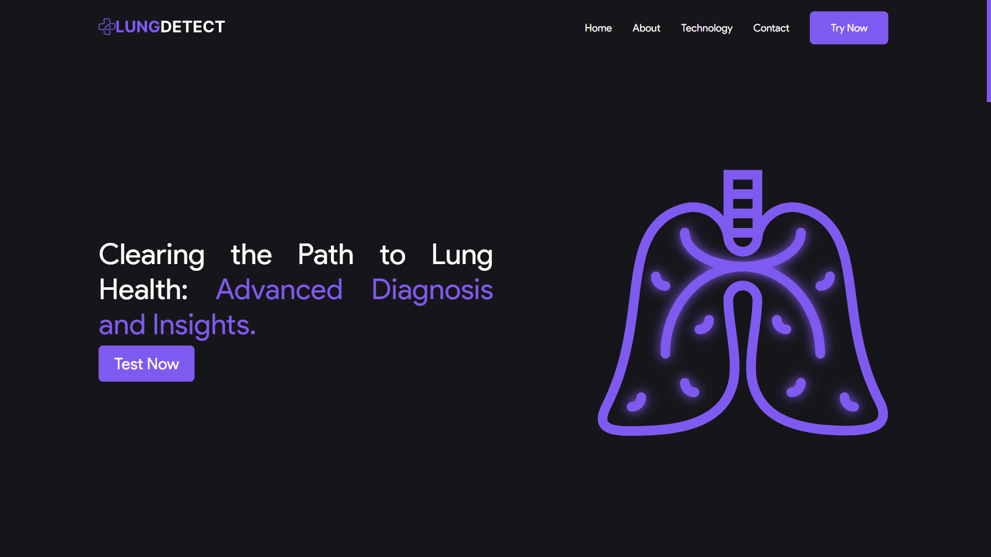

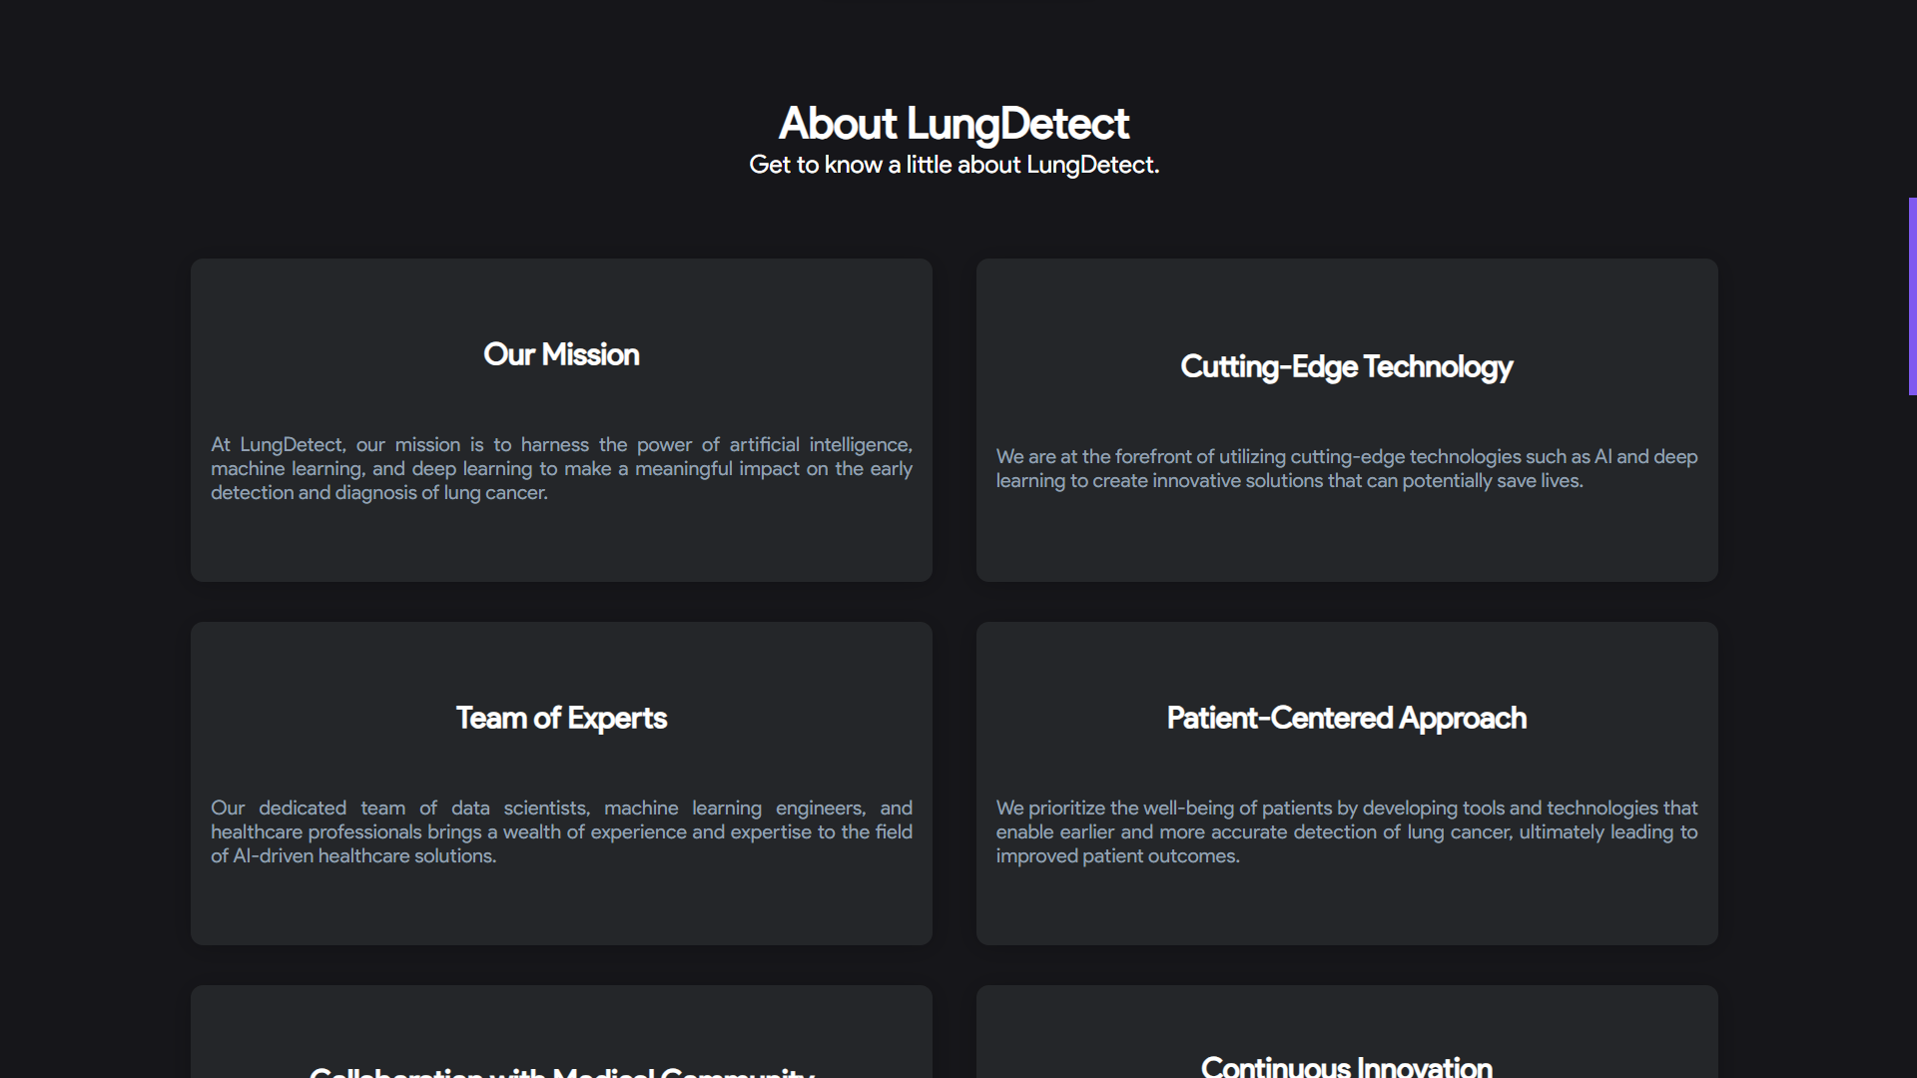

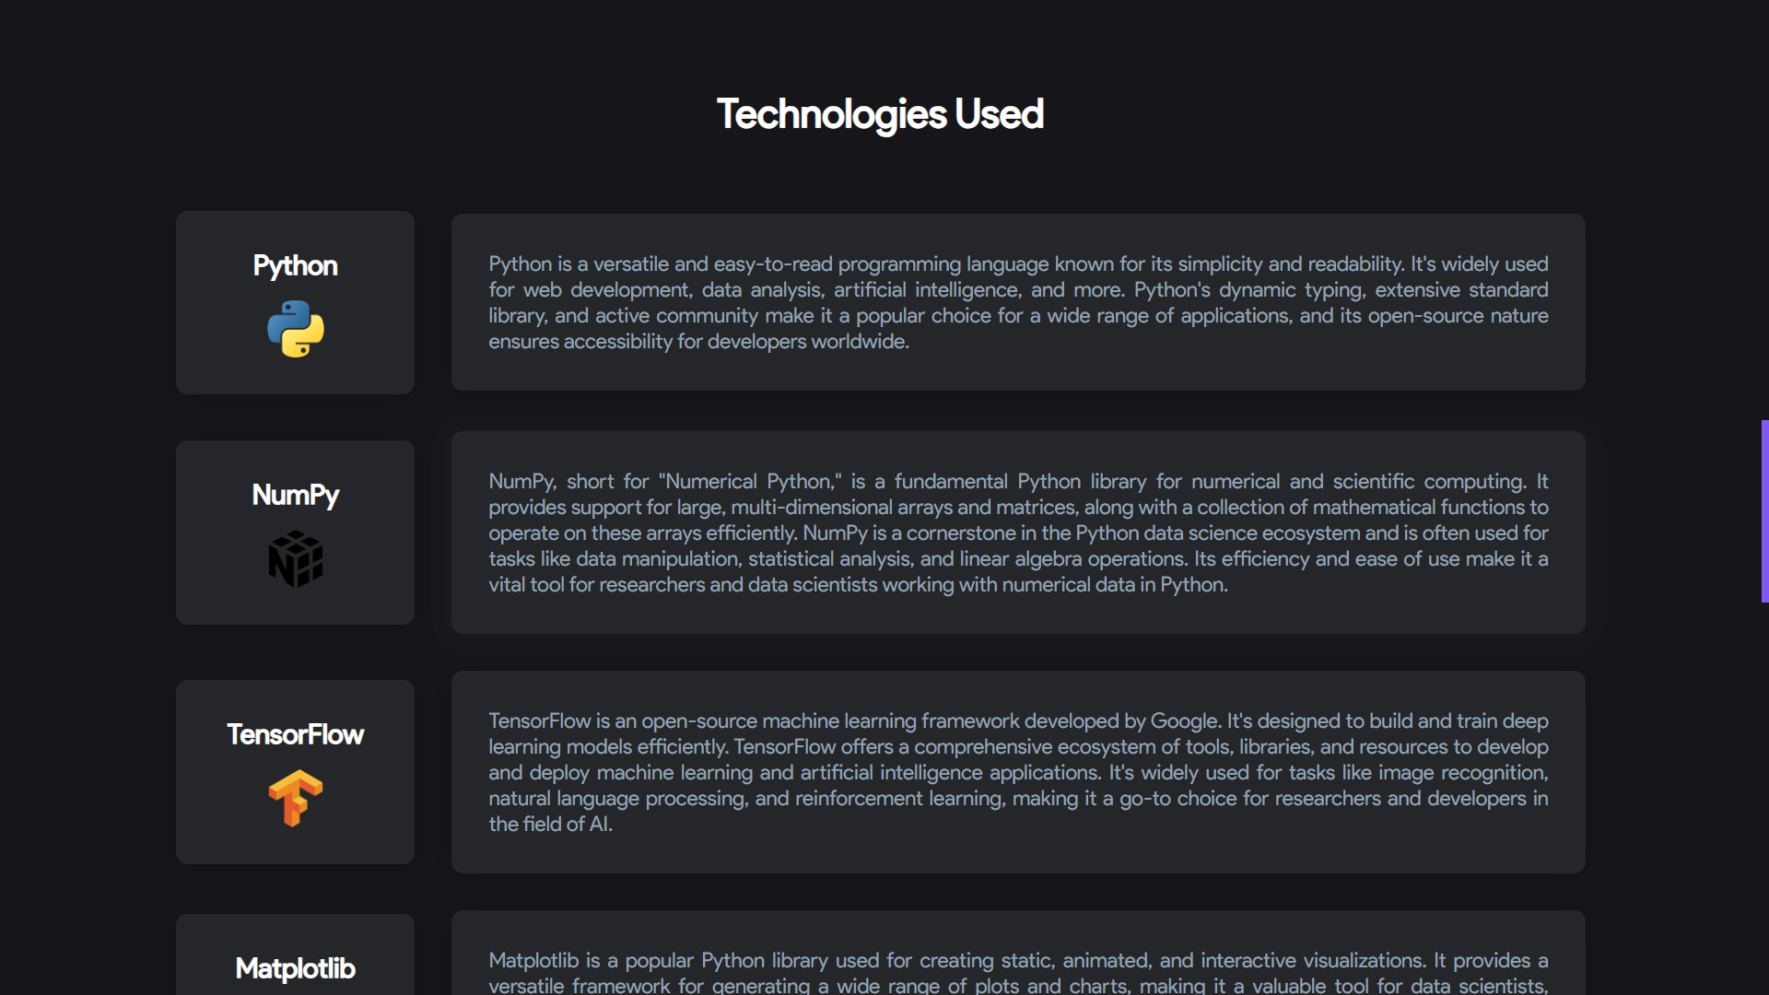

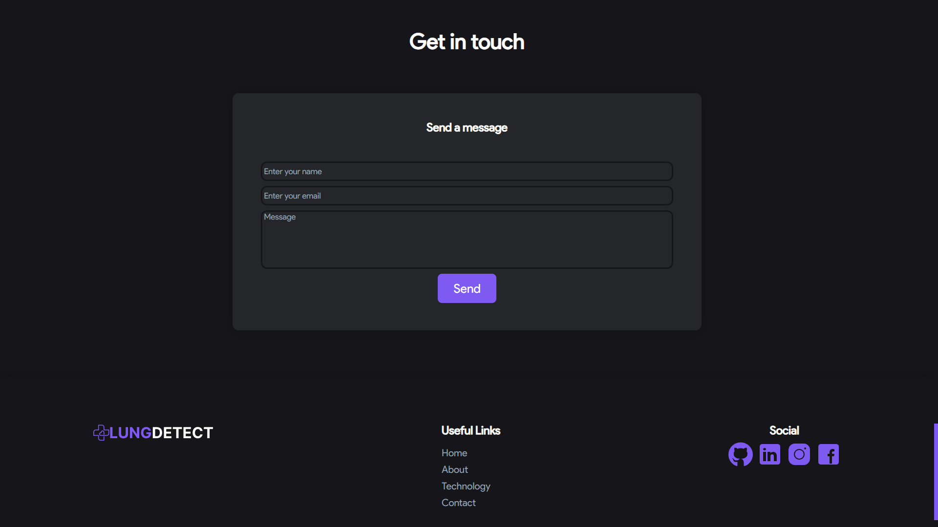

**Predictions page**

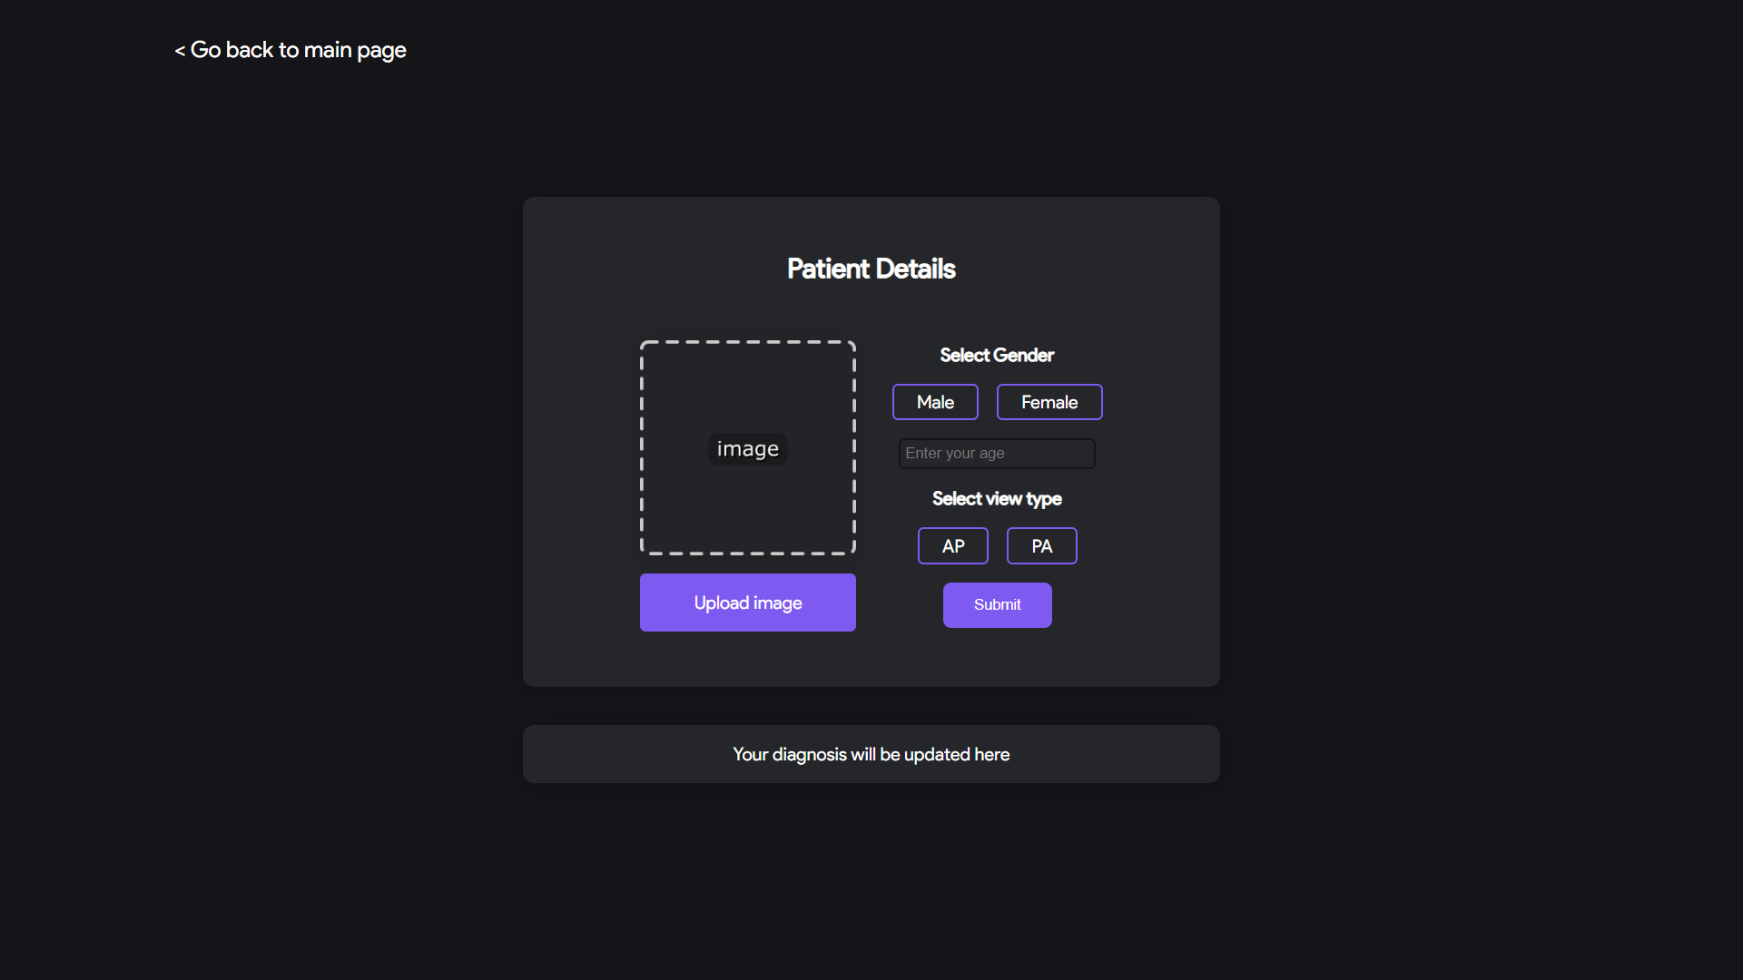

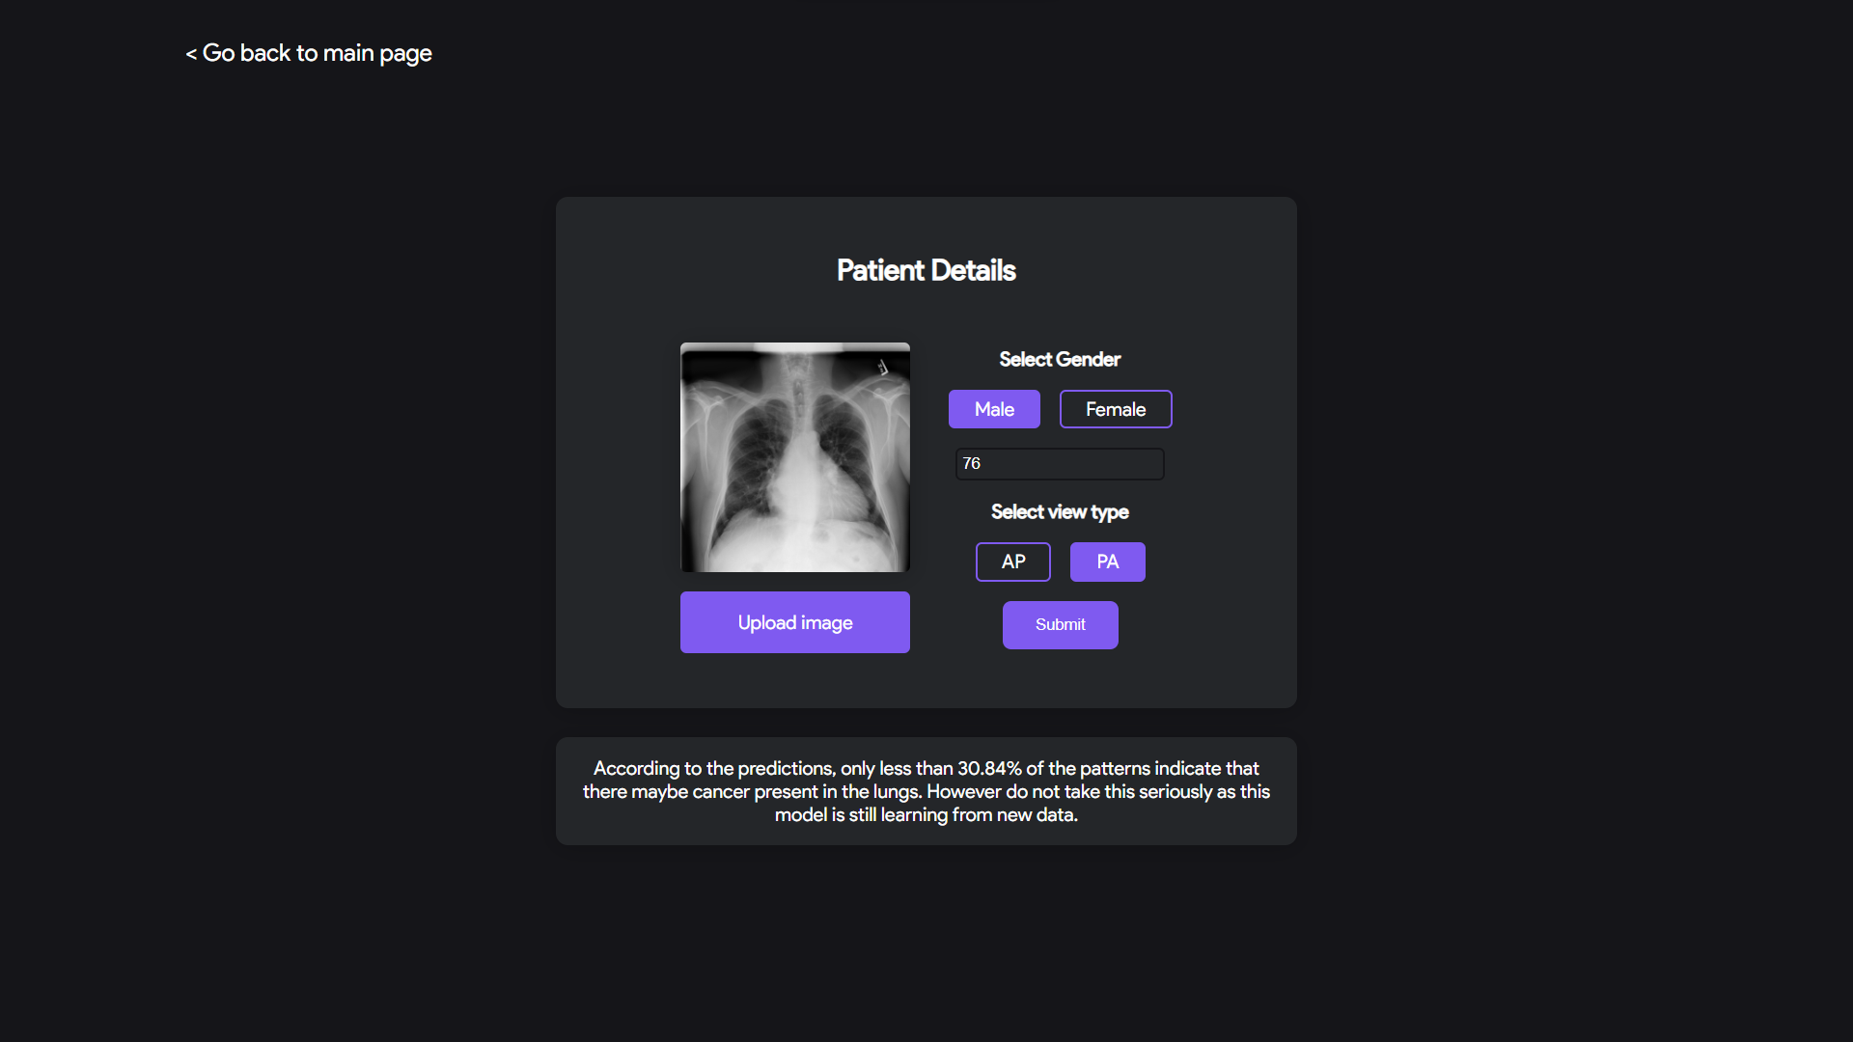

**9. Future Enhancements**

As technology continues to evolve, and as we gain more insights into the field of lung cancer detection, the Lung Cancer Detection System can be enhanced and expanded to provide even more value to healthcare professionals and patients. Here are some promising directions for future development:

* **Integration with Multiple Imaging Modalities:** While the system currently focuses on X-ray image analysis, future enhancements could involve the integration of other imaging modalities such as CT scans, MRIs, or PET scans. This broader range of data sources would provide a more comprehensive view for diagnosis.
* **Continuous Learning:** Incorporate mechanisms for continuous learning of the machine learning models. Frequent updates and retraining on new data can improve accuracy and adapt to evolving patterns of lung cancer.
* **Multilingual Support:** Extend the user interface to support multiple languages, making the system accessible to a broader audience of healthcare professionals globally.
* **Telemedicine Integration:** Integrate the Lung Cancer Detection System with telemedicine platforms, enabling remote consultations and diagnostics. This can enhance healthcare access, especially in underserved areas.
* **Mobile Application:** Develop a mobile application that allows healthcare professionals to capture and upload images directly from mobile devices, making it easier to use the system in various clinical settings.
* **Enhanced Reporting:** Enhance the diagnostic reports with more detailed information, including lesion size, growth rate, and treatment recommendations. Interactive visualizations can aid in data interpretation.
* **Cloud-based Deployment:** Consider a cloud-based deployment model, which can offer scalability, redundancy, and accessibility from anywhere with an internet connection.
* **Collaboration and Second Opinions:** Enable collaboration features that allow multiple healthcare professionals to review and discuss cases within the system. Second-opinion capabilities can improve diagnostic accuracy.
* **Regulatory Compliance:** Stay updated with regulatory requirements in the healthcare and medical software domain. Comply with standards such as HIPAA and FDA regulations, ensuring data security and patient safety.
* **Research Collaboration:** Collaborate with research institutions and medical experts to continually refine and validate the system's algorithms and performance against a broader dataset.
* **AI Explainability:** Implement AI explainability features to provide insights into how the machine learning model arrives at its conclusions. This can increase trust and transparency in the system.
* **Education and Training:** Develop educational resources and training materials to help healthcare professionals make the most of the system's capabilities. This can include online courses or webinars.
* **User Feedback Mechanism:** Incorporate a feedback mechanism within the user interface to gather suggestions and insights from healthcare professionals, aiding in iterative improvements.

These future enhancements demonstrate your commitment to ongoing development and innovation in the field of lung cancer detection. They also highlight your dedication to improving patient care and the effectiveness of healthcare providers in combatting this critical health issue.

**10. Conclusion**

In conclusion, the Lung Cancer Detection System represents a pivotal milestone in the realm of healthcare technology. This innovative project, developed with unwavering dedication, brings forth a powerful tool designed to transform the early detection of lung cancer. As this documentation encapsulates the journey, purpose, and capabilities of the system, it is imperative to reflect on the significance of this endeavor.

Our system leverages cutting-edge technologies, including machine learning and medical image analysis, to analyze medical images such as X-rays and aid healthcare professionals in the timely identification of potential lung cancer lesions. With a user-friendly interface and rigorous testing, it is poised to become an invaluable asset in clinical practice.

Throughout the development process, we have adhered to the highest standards of accuracy, functionality, and security. The system's performance has been rigorously tested, ensuring that it meets and surpasses its defined objectives.

The journey does not end here; it merely signifies the beginning of a commitment to continuous improvement and advancement. Future enhancements, such as integration with multiple imaging modalities, real-time analysis, and cloud-based deployment, demonstrate our dedication to staying at the forefront of healthcare technology.

We extend our gratitude to the healthcare professionals, researchers, and experts who have contributed their insights and expertise to make this project a reality. Together, we endeavor to make a meaningful impact in the fight against lung cancer, improving patient outcomes and enhancing the quality of care.

As we move forward, this Lung Cancer Detection System stands as a testament to the potential of technology to revolutionize healthcare. It is not merely a system but a beacon of hope, embodying our collective commitment to the well-being of patients and the pursuit of excellence in medical science.

In the spirit of innovation and dedication to human health, we invite you to explore, utilize, and contribute to this system's ongoing evolution. Together, we can forge a brighter future in the early detection and treatment of lung cancer, saving lives and making a profound difference in the world of healthcare.

**11. Bibliography**

* <https://www.geeksforgeeks.org/>
* <https://www.freecodecamp.org/learn>
* NIH sample Chest X-rays dataset, <https://www.kaggle.com/nih-chest-xrays/sample>
* NIH full Chest X-rays dataset, <https://www.kaggle.com/nih-chest-xrays/data>
* <https://www.cdc.gov/cancer/lung/statistics/>
* <https://www.nih.gov/news-events/news-releases/nih-clinical-center-provides-one-largest-publicly-available-chest-x-ray-datasets-scientific-community>
* <https://www.youtube.com/@campusx-official>
* <https://www.youtube.com/@CodingLane>
* <https://www.w3schools.com/>
* <https://www.slideshare.net/drvikrampatil/approach-to-chest-xray-and-interpretation>
* Max Jaderberg, Karen Simonyan, Andrew Zisserman, Koray Kavukcuoglu. Spatial Transformer Networks. <https://arxiv.org/abs/1506.02025>
* Spatial transformer: <https://github.com/hello2all/GTSRB_Keras_STN>